# Influence of bridge on vehicle acceleration

To gain an understanding of what characteristics of bridge profile are influential to vehicle acceleration and subsequently amplification of bridge response, the profile from an actual profile (I76 Viaduct) will be examined. In an effort to reduce computational expenditure, the vehicle response without the structure will be compared to that with the structure included. If the differences are negligeable, further simulations will be performed with the bridge structure excluded.

As can be seen from the above plot, the majority of the vehicle response is due to the profile.

The rigid road was modeled as a beam with supports along its length. In an effort to evaluate LUSAS’ ability to simulate this rigid road, a Matlab script was created that simulates a quarter-car model over a given profile. These results matched well with the LUSAS simulation.

(Agostinacchio, Ciampa, and Olita 2014) Details matlab work for determining vehicle dynamic force due to profile.

## Influence of profile character on vehicle acceleration

Since a vehicle’s response to a bridge’s roadway is dominated by the roadway profile, we can study the interaction between vehicle suspension and the nature of the profile.

<http://www.diva-portal.org/smash/get/diva2:962705/FULLTEXT01.pdf>.

First let’s examine the difference between an artificially generated profile vs the measured.

The power spectral density of the profile is calculated using MATLAB functions.







Using the ISO 8608 standard we may classify this profile by fitting a curve of the form Gd(n)=Cn-w. The exponent is usually fixed to 2, but we may allow it to vary for best fit. (Andren 2006)



Matlab’s curve fitting tool was used to acquire a linear fit for the log of the data, which was subsequently transformed to the form given above. The fitted data was metric to match the ISO standards for ease of interpretation and comparison. The fitted equation was as follows:

C is usually identified as the PSD value at the reference spatial frequency: 0.1 cycles/meter. Therefore, for the above equation, C would be 1.156*10-4 or 115.6 (10-6) m3 for a waviness of 2.495. For a waviness of 2, the roughness coefficient (C) equals 13.7 (10-6) m3. According to ISO 8608, these values correspond to average and very good road profiles (Loprencipe and Zoccali 2017). Clearly, the ISO 8608 standard in inadequate at judging how a roadway effects vehicles, and the waviness should not be restricted to 2 if a true characterization of the profile is desired.

Using the fitted PSD functions we can generate an artificial profile. The following equations were used in a matlab script to obtain artificial profiles (Loprencipe and Zoccali 2017):

Where *z* is the elevations profile in m, Ωi are the angular spatial frequencies in rad/m, φi are the phase angles in rad, the amplitudes *Ai* are defined by equation 2, and *Φ*(Ωi) is the fitted PSD value at the angular spatial frequency *Ωi*.

The resulting profile is displayed below compared to the measured profile.

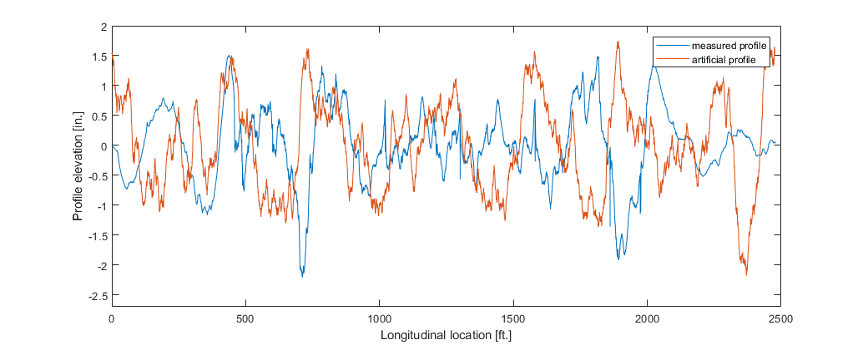

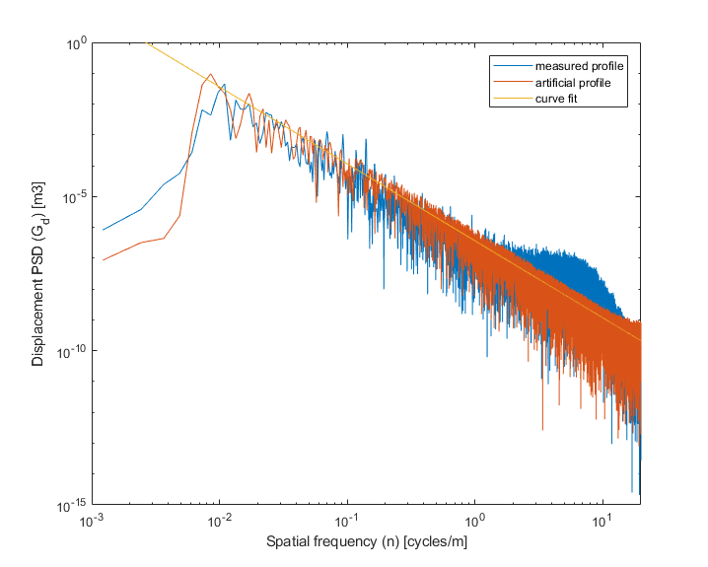

The PSD was computed for the artificial profile and compared to that of the measured profile, and good agreement is exhibited.

To examine whether a profile characterized by two parameters (C and w) is indicative of the response induced in a traversing vehicle, we examined the acceleration of a quarter-car model over the generated profile.

The plot below shows the induced acceleration of the quarter-truck model traversing over the measured I76 profile as well as the acceleration when traversing over the artificially generated model.

As can be seen, the artificially generated profile results in similar magnitude vibrations in the truck model.

Clearly the waviness (w) factor is very important in terms of the behavior of the vehicles. The artificial profile had amplitudes based on the fit curve for most of the frequency spectrum, however, there may be regions that are more important to capture than others. The next question is what frequency content is most influential. Perhaps a function should be fitted to only a portion of the measured profile that is most influential to vehicle response (i.e. fit the same form of function to spatial frequencies between .02 and .04 cycles/ft).

To start we will look at the vehicle response to different profiles. The frequency content of all profiles will be described by the same function but will each include a different frequency band, in an effort to establish the range of frequencies that are most influential to large amplitude, low frequency vehicle oscillations. The frequency bands are listed in the following table.

Table : Bounds of frequency content for profile categories (spatial frequency/wavelength (m)

|  |  |  |
| --- | --- | --- |
|  | Lower  Bound | Upper  Bound |
| 1 | .001/1000 | 40/0.025 |
| 2 | 0.01/100 | 40/0.025 |
| 3 | 0.02/50 | 40/0.025 |
| 4 | 0.05/20 | 40/0.025 |
| 5 | 0.1/10 | 40/0.025 |
| 6 | 0.25/4 | 40/0.025 |

These categories examine the influence of low frequency (large wavelength) profile features. To examine the influence of high frequency (short wavelength) profile features, the following profiles were created and analyzed.

|  |  |  |
| --- | --- | --- |
|  | Lower  Bound | Upper  Bound |
| 1 | 0.05/20 | 40/0.025 |
| 2 | 0.05/20 | 10/0.1 |
| 3 | 0.05/20 | 2/0.5 |
| 4 | 0.05/20 | 1/1 |
| 5 | 0.05/20 | 0.5/2 |
| 6 | 0.05/20 | 0.25/4 |

Simulations of both of these category sets showed that the vehicle acceleration is greatly dependent on profile features with wavelengths between 4 and 10 meters (10 – 30 ft), and analyses should include wavelengths from 1 to 20 meters (when considering vehicle bounce).

Therefore, when analyzing a profile, it would be most advantageous to compute the PSD and examine the power associated with spatial frequency content between the influential wavelengths. This could be accomplished by curve fitting a function of the same form as previously presented, but only to the PSD data within a range of 0.05 and 1. The terms of this fitted function could be used as indicators for a potentially problematic profile.

In light of this, I propose 2 parameters to describe the profile. The first, C10, is the value of the fitted function at a wavelength of 10 meters (0.1 spatial frequency). The exponential term, w (or waviness) remains the same as in the ISO 8608 standard. The C10 value for the function fitting our measured profile is 115 (10-6 m3), and thereby classified as “good” by the ISO 8608 standard.

First, we shall investigate the influence of the term C10 by examining the effect of the following profile categories on vehicle acceleration.

|  |  |  |  |
| --- | --- | --- | --- |
|  | C10 Value (m3) | ISO 8608 Class | Max Accel. (g) |
| 1 | 10-6 | A | 0.08 |
| 2 | 10-5 | A | 0.24 |
| 3 | 10-4 | B | 0.77 |
| 4 | 10-3 | D | 2.45 |
| 5 | 10-2 | F | 7.74 |

For this run, the waviness (w) will be held at 2.0 to keep with the ISO standards.

Therefore the profiles will be created based on PSD values specified by the following equation:

|  |  |
| --- | --- |
| ISO 8608 class | C10 (10-6 m3) |
| A (very good) | <32 |
| B (good) | 32–128 |
| C (average) | 128–512 |
| D (poor) | 512–2,048 |

As can be deduced from the above table, the C10 parameter has a great influence on the vehicle acceleration. To fully characterize this parameter space, let’s repeat this simulations for each of the given ISO classes and for different speeds (ranging from 10 m/sec to 40 m/sec)

|  |  |  |
| --- | --- | --- |
|  | ISO 8608 class | C10 Value (10-6 m3) |
| 1 | A (very good) | 10 |
| 2 | B (good) | 100 |
| 3 | C (average) | 300 |
| 4 | D (poor) | 600 |

To understand the effect of the waviness factor we examined the vehicle response for a variety of different waviness factors while holding the C10 value at 1x10-4. The following table describes the simulation case. Each was completed at the 7 different speeds presented in the previous study.

|  |  |
| --- | --- |
|  | Waviness (w) |
| 1 | 1.5 |
| 2 | 2.0 |
| 3 | 2.5 |
| 4 | 3.0 |
| 5 | 3.5 |
| 6 | 4.0 |

This range was chosen after consideration of (Loprencipe and Zoccali 2017) and the specified value of 2.0.

From the above graph we can deduce that waviness may have an effect on vehicle acceleration, but the relationship depends on vehicle speed. This makes sense, since a higher waviness indicates a profile that has more low frequency content, and thus would cause resonance in the vehicle at higher speeds. The C10, in contrast, has a consistent effect on vehicle acceleration, with higher values leading to greater vehicle acceleration. This relationship, however, is likely dependent on vehicle dynamic characteristics as well.

To examine the possible effect on the relationship between the waviness value and vehicle acceleration, we repeated the above simulations for several other vehicles. These suspension parameters were adjusted to produce vehicles with varying frequencies for their first mode of vibration. *Note that vehicle 1 has suspension parameters matching those of the truck that was used during field testing.

|  |  |  |  |  |  |  |  |
| --- | --- | --- | --- | --- | --- | --- | --- |
| Parameter | Vehicle 1 | Vehicle 2 | Vehicle 3 | Vehicle 4 | Vehicle 5 | Vehicle 6 | Units |
| Truck Mass | 20865 | 20865 | 20865 | 11068 | 4309 | 9072 | Kg |
| Suspension Stiffness | 7005080 | 823000 | 3327413 | 7005080 | 4378175 | 1436041 | N/m |
| Suspension Viscosity | 53529 | 18348 | 36892 | 38986 | 19232 | 15980 | N.s/m |
| Axle/Wheel Mass | 907 | 907 | 907 | 907 | 907 | 907 | Kg |
| Wheel Stiffness | 14010160 | 14010160 | 14010160 | 14010160 | 14010160 | 14010160 | N/m |
| 1st Nat. Freq. | 2.9 | 1 | 2 | 4 | 5 | 2 | Hz |

For each vehicle, the effect of waviness of vehicle response differed. The response of vehicles 3 and 6 were very similar and waviness had a similar effect on the acceleration of both vehicles (as expected since they had the same natural frequency).

## Summary

The expected vehicle acceleration is a function of the spatial frequency content in the road profile, which can be described by the ISO 8608 standards (C10 and w). However, the vehicle acceleration is also a function of vehicle natural frequency, and thus the vehicle should be chosen carefully before analysis is carried out.

As we are principally concerned with bridge response, we must examine the variation of bridge response in relation to loading frequency (i.e. frequency of vehicle oscillations that is crossing bridge).

# Profile effect on bridge response

Hypothesis: the maximum dynamic amplification occurs when the profile has spatial frequency that excites the natural frequency of the vehicle, which, is also close to the frequency of the bridge.

To begin with, we will create several scenarios in which an idealized profile is paired with a vehicle model, such that the spatial frequency creates vibration in the vehicle at that vehicle’s natural frequency. We will compare responses from this profile to a profile with additional frequency content to examine if the “corresponding spatial frequency” produces the majority of response.

The table below lists the set of ideal profiles investigated as well as the frequency they produce at certain speeds

|  |  |  |  |
| --- | --- | --- | --- |
| Profile wavelength (ft) | Frequency @ 60ft/s | Frequency @ 90ft/s | Frequency @ 120ft/s |
| 20 | 3.0 Hz | 4.5 Hz | 6 Hz |
| 30 | 2.0 Hz | 3.0 Hz | 4 Hz |
| 40 | 1.5 Hz | 2.25 Hz | 3 Hz |
| 60 | 1 Hz | 1.5 Hz | 2 Hz |

The following vehicles were used to analyze the profiles.

|  |  |  |  |  |  |  |
| --- | --- | --- | --- | --- | --- | --- |
| Parameter | Vehicle 1 | Vehicle 2 | Vehicle 3 | Vehicle 4 | Vehicle 5 | Units |
| Truck Mass | 20865 | 20865 | 9072 | 20865 | 20865 | Kg |
| Suspension Stiffness | 1853807 | 3327413 | 1436041 | 7415253 | 29661012 | N/m |
| Suspension Viscosity | 27537 | 36892 | 15980 | 55075 | 110150 | N.s/m |
| Axle/Wheel Mass | 907 | 907 | 907 | 907 | 907 | Kg |
| Wheel Stiffness | 14010160 | 14010160 | 14010160 | 14010160 | 14010160 | N/m |
| 1st Nat. Freq. | 1.5 | 2 | 2 | 3 | 6 | Hz |

It seems like the maximum vehicle response does not always occur for conditions causing the forcing function (i.e. profile and velocity) to match the frequency of the vehicle.

To examine the effect on a structure, several different models of idealized simple structures will be constructed. These structures will consist of a single beam with equal mass (mass/length), equal length, but different stiffnesses, and therefore different natural frequencies.

The mass per unit length was chosen to match the I76 viaduct. The total vertical reaction for a 2 span, 280 ft. section of the viaduct summed to 1.91x10^6 lb. This resulted in 568 lbf/in. Therefore, the beam models will have a unit mass of 560 lbf/in.

|  |  |  |  |  |  |  |
| --- | --- | --- | --- | --- | --- | --- |
|  | Beam 1 | Beam 2 | Beam 3 | Beam 4 | Beam 5 |  |
| Moment of Inertia (I) | 139.0E3 | 247.0E3 | 560.0E3 | 1.0E6 | 2.32E6 | in4 |
| Modulus (E) | 29000 | | | | | ksi |
| Length | 110 | | | | | ft |
| Unit weight | 560 | | | | | lbf/in |
| 1st Natural Freq. | 1.5 | 2 | 3 | 4 | 6 | Hz |

So, the hypothesis holds up in most cases. But vehicle 5 is being excited by speed/wavelength ratios of 3 Hz. To better understand what is going on we looked at the frequency content of the contact force between the vehicle and bridge by computing the PSD.

A peak frequency content is easily observable:



Question: why does the 6Hz vehicle accelerate more when traveling over a profile that is inducing a 3Hz forcing function, than when traversing a profile that is inducing a 6Hz forcing function, or even more than the 3Hz vehicle when subjected to a 3Hz forcing function?

As vehicle stiffness increases, so does the vehicle acceleration and consequently the bridge deflection also increases. However, the peak response is happening at a forcing frequency of 3.5 Hz. This is with different vehicle natural frequencies, different bridge natural frequencies and different speeds on a given profile. Looking at the time history of the vehicle acceleration, it appears to resonate and the acceleration builds as it traverses the approach profile.

What is so special about this 3.5 Hz forcing frequency that it’s causing so much vehicle response.

# MATLAB-LUSAS Check

Let’s compare matlab response to Lusas. Also let’s look at the frequency content of the vehicle acceleration.

So I had to revisit Matlab vs Lusas. There seems to be a discrepancy when vehicle damping is under 20%. Must look into matrices, specifically the damping term.

Matlab code looks good. Do another check against lusas with a control vehicle/test case.

Control Cases:

|  |  |  |
| --- | --- | --- |
| Vehicles | Profiles | Speeds |
| Vehicle 2 | 30 ft | 60 ft/sec |
| Vehicle 5 | 40 ft | 90 ft/sec |
| Vehicle 7 |  |  |

Double checked matlab and lusas models for vehicle, and changed lusas model fixity such that longitudinal motion was restricted (i.e. eliminated stretch modes). Matlab is now in agreement with LUSAS.

LUSAS and matlab checked with pure harmonic profiles as well as with an I76 profile. Once the longitudinal rigidity was fixed, the LUSAS and Matlab was in extremely close agreement.



(Right on top of each other)

# Investigating the 6Hz vehicle phenomenon

i.e. why does a 6Hz vehicle cause so much more acceleration than other vehicles, and more on a profile causing ~3Hz forcing frequency than on a 6 Hz profile.

From the data, it appears like vehicles with higher stiffness generally lead to higher vehicle acceleration. There is an increase in acceleration when the vehicle frequency corresponds with the forcing frequency (due to profile).

Let’s look at the following time history records of vehicle acceleration and bridge midspan deflection.

|  |  |  |  |
| --- | --- | --- | --- |
| Vehicle | Speeds (in/sec) | Forcing Freq | Bridge Frequency |
| Vehicle 4 (3 Hz) | 600 | 2.5 Hz | 1.5 Hz |
| Vehicle 5 (6 Hz) | 720 | 3 Hz | 3 Hz |
|  | 840 | 3.5 Hz |  |

The simulations of the cases listed above showed that 6 Hz vehicle interacted with the bridge more. The plot below illustrates this.

However, it is not clear why there is so much more acceleration occurring on the bridge/vs profile early in the time history when the approach should behave rigidly and thus match the “profile only” record.

Look into comparing approach with rigid structure vs “floating” approach path.

**After looking into it, I suspect that this may be a simulation step size issue for which vehicle acceleration is especially sensitive to with these special conditions (i.e. harmonic input near resonance).**

**I looked at a realistic profile to determine if this time-step size effect was still significant, and it was.**

The step-size is dependent on the highest frequency of included modes. Therefore, enough modes must be solved for to obtain a satisfactory (converge with matlab solution) simulation when including profile effects.

The sampling frequency/simulation time-step size is related to the frequency of the highest included mode by the following: fs = 2*freqmax . A sampling frequency greater than 70 Hz produces vehicle acceleration that closely matches that from the rigid model (which has a sampling frequency of 1485 Hz). Therefore, a mode of vibration of at least 35 Hz should be included in the simulation.

However, even this sampling frequency (70 Hz) is not sufficient for harmonic profiles.

Let’s look at vehicle response to harmonic profiles, but compare amplification rather than vehicle acceleration. The amplification will be computed as vehicle acceleration divided by rigid vehicle acceleration. Rigid vehicle acceleration (also referred to as profile acceleration) is the second derivative of the profile divided by the vehicle speed.

Test profiles will be broken into simple harmonic (i.e. singular frequency content), complex harmonic (i.e. multiple frequencies with amplitude distributed so as to produce equal rigid vehicle accelerations), and ranged harmonic (i.e. frequency content within specified range, amplitudes distributed by a specified function (logarithmic like ISO standard)).

Let’s break down the contribution to bridge response into rigid vehicle response to profile, dynamic vehicle response to profile, and dynamic interaction of bridge and vehicle. This last component includes the dynamic behavior of the vehicle due to bridge motion (energy transfer, time dependent geometry (i.e. vertical bridge displacement leading to profile component)). Furthermore, the final component is dependent on the first two components as well as duration of loading (i.e. how long the vehicle is on the span) bridge damping, and bridge frequencies.

Hypothesis: with normal profiles that would be expected on roadways (i.e. not perfectly harmonic) the acceleration of the vehicle would be almost entirely due to the profile, and the contribution from bridge deflection/vibration would be negligible. Furthermore, due to the transient nature of a realistic profile, the acceleration of the vehicle is unlikely to resonate and increase to very high values. Also, as the acceleration of the vehicle increases the suspension of the vehicle becomes non-linear and damping increases. When the acceleration exceeds 1 G of acceleration, the vehicle would lose contact with the bridge roadway surface, which is not accounted for in this linear model.

The amplification can be broken into components as follows:

1. The profile alone generates acceleration of the vehicle, thereby increasing the load felt by the bridge. This acceleration is based on profile spatial frequency content, vehicle speed, and vehicle suspension stiffness.
2. This effect is amplified under special conditions:
   1. The profile excites the vehicle’s natural frequency
   2. The frequency of the vehicle’s contact force matches (or is near) the bridges natural frequency.

However, since the vehicle is only on the span for a short time, only a few cycles of vehicle bounce will be experienced by the bridge. Therefore the contribution of special condition b is limited.

Let’s also look into the possibility of a shift in the loading frequency due to the vehicle motion.

Finally, closed-form solutions should be done for a few SDOF cases where the profile is converted into a loading force.

<https://www.researchgate.net/profile/Peter_Andren/publication/245401955_Power_spectral_density_approximations_of_longitudinal_road_profiles/links/553637270cf20ea35f112d35/Power-spectral-density-approximations-of-longitudinal-road-profiles.pdf>